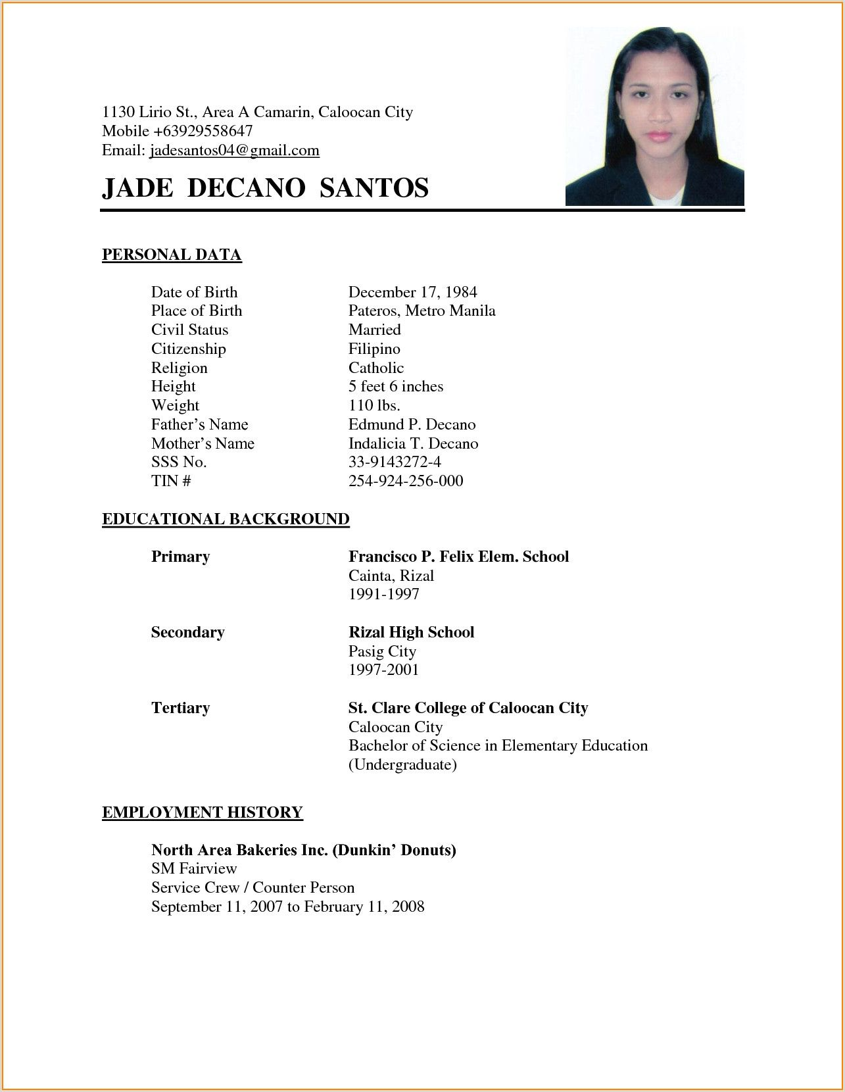1130 Lirio St., Area A Camarin, Caloocan City

Mobile +63929558647

Email: jadesantos04@gmail.com

**JADE DECANO SANTOS**

PERSONAL DATA

Date of Birth December 17, 1984

Place of Birth Pateros, Metro Manila

Civil Status Married

Citizenship Filipino

Religion Catholic

Height 5 feet 6 inches

Weight 110 lbs.

Father's Name Edmund P. Decano

Mother's Name Indalicia T. Decano

SSS No. 33-9143272-4

TIN 254-924-256-000

**EDUCATIONAL BACKGROUND**

Primary Francisco P. Felix Elem. School

Cainta,

1991-1997

**Secondary** Rizal High School

Pasig City

1997-2001

**Tertiary** St. Clare College of Caloocan City

Caloocan City

Bachelor of Science in Elementary

Education (Undergraduate)

**EMPLOYMENT HISTORY**

**North Area Bakeries Inc. (Dunkin' Donuts)**

SM Fairview

Service Crew / Counter Person

September 11, 2007 to February 11, 2008